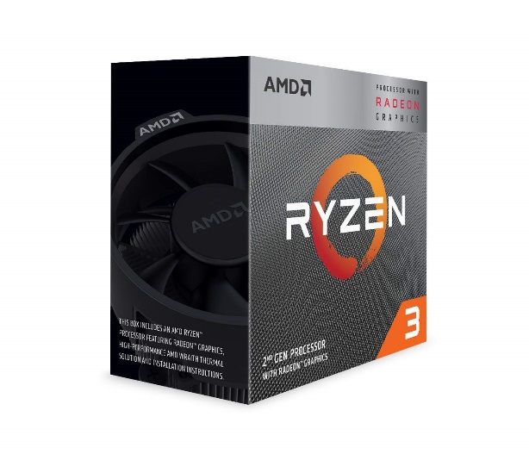

Inner

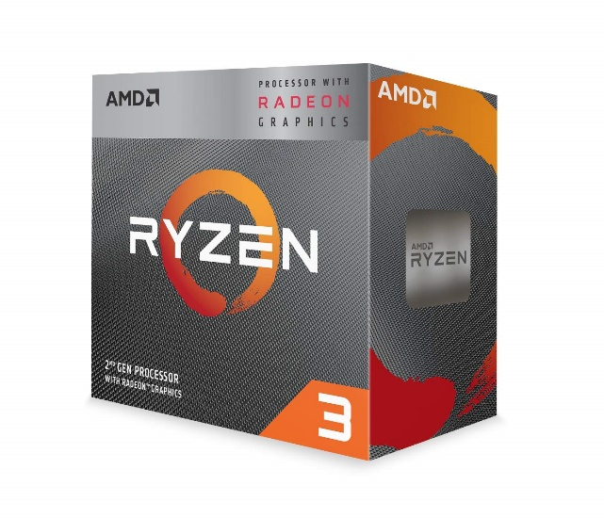

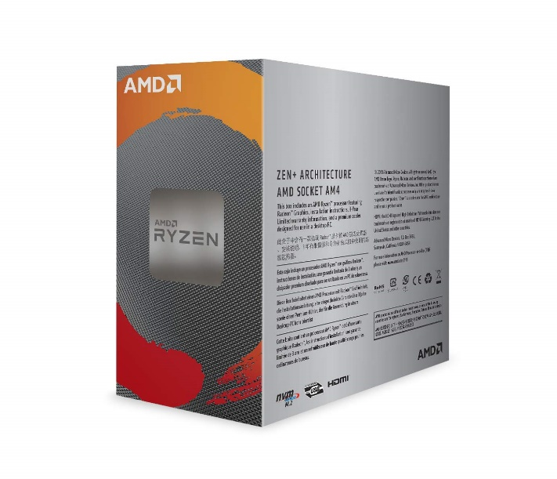

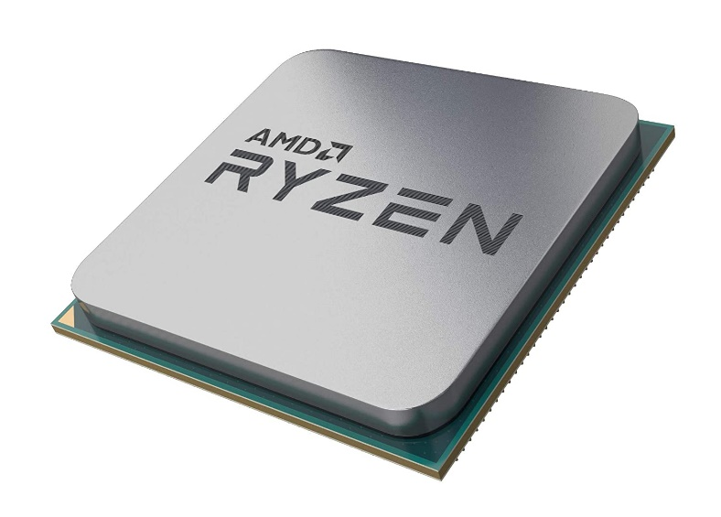\

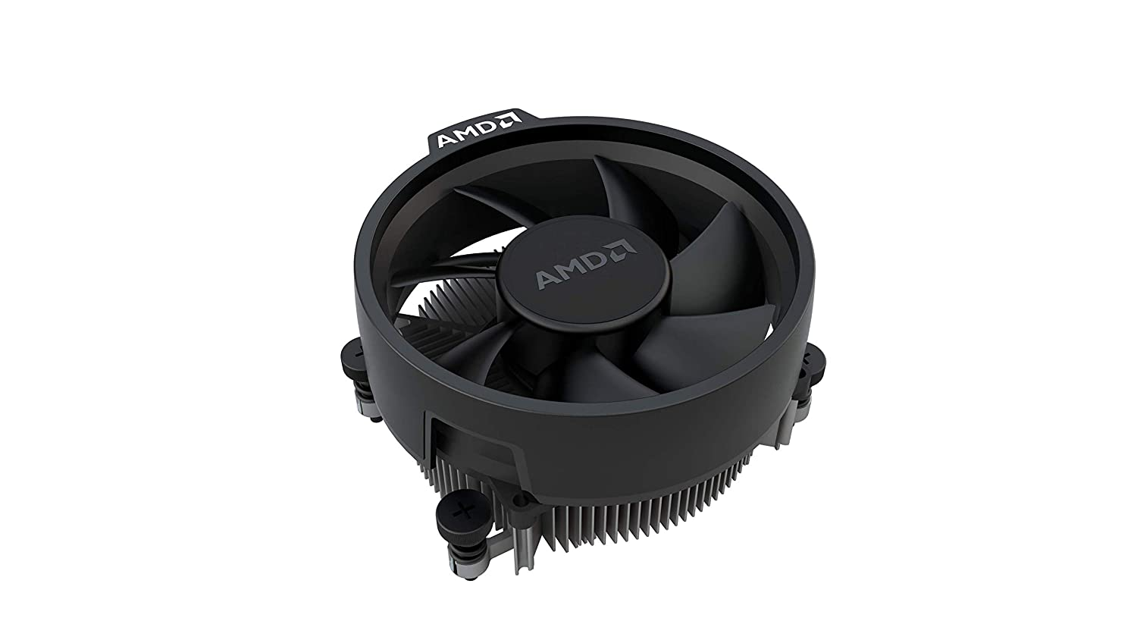

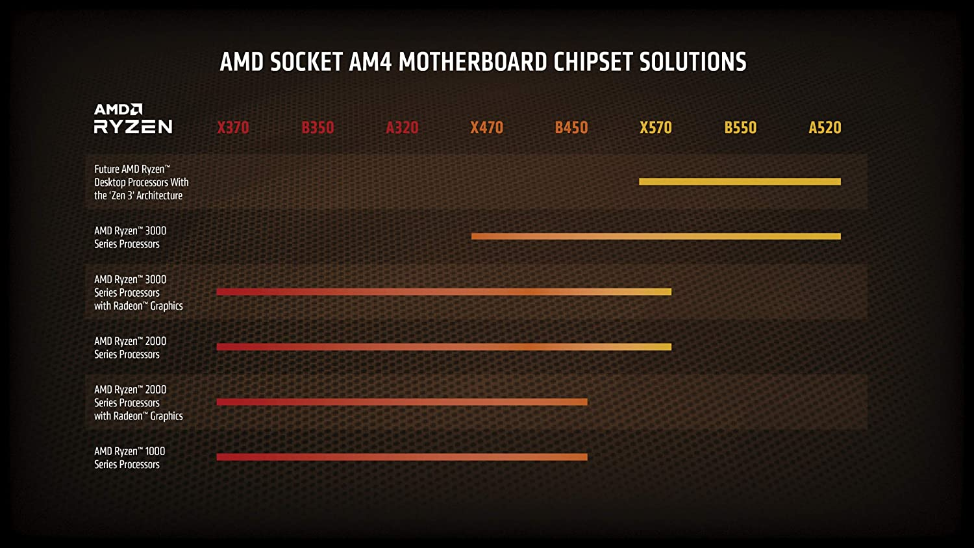

AMD Ryzen 3 3200G with RadeonVega 8 Graphics Desktop Processor 4 Cores up to 4GHz 6MB Cache AM4 Socket (YD320GC5FHBOX)

|  |  |
| --- | --- |
| M.R.P.: | ₹13,500.00 |
| Deal of the Day: | ₹9,999.00   |  |  | | --- | --- | | Brand | AMD | | CPU Manufacturer | AMD | | CPU Model | Ryzen 3 3200G | | CPU Socket | Socket AM4 | | Platform | Windows 10 |   **About this item**   * 4 Cores & 4 Threads * Base Clock: 3.6GHz, Max Boost Clock: up to 4GHz, 6MB Cache, TDP: 65W * System Memory Specification: 2933MHz, System Memory Type: DDR4, Memory Channels: 2 * Socket: AM4, Motherboard Compatibility: AMD 300, 400,serles chipset based motherboards * Graphics: AMD Radeon Vega 8 Graphics, Heatsink Fan: Wraith Stealth, Warranty: 3 Years * 3 Years Brand Warranty. For Technical Support : Please Contact : Tel: +91-80-67030050 (Mon-Fri: 09:00 - 17:00 IST); Expect Delayed Response due to ongoing COVID Crisis * For all performance-related issues in: AMD Processor: Please reach out via AMD brand home page > Drivers & Support > Customer Support  (Technical & Warranty help) > Contact Support > Online Service Request In case you are not satisfied the resolution provided by the above brands, please reach back to Amazon Customer service for next steps. |